RESTAURANT ORDER MANAGEMENT SIMULATOR


Group Members
Talal Ali — <Roll No>
Syed Muhammad Sarim — <Roll No>
Muhammad Sami — <Roll No>

Supervised by
Ms. Anaum Hamid
FAST School of Computing
National University of Computer and Emerging Sciences

1. Introduction
The Restaurant Order Management Simulator is an Operating Systems project designed to model a professional kitchen environment using high-level concurrency. It simulates the producer-consumer problem by having multiple Waiters (producers) and Chefs (consumers) interact through a shared order buffer.
Purpose: To demonstrate effective use of POSIX threads and synchronization primitives to prevent data corruption.
Scope: Handling concurrent task generation, resource allocation, and thread-safe queue management.

2. System Architecture & File Logic
This section breaks down the responsibility of each file in the project directory, explaining its core logic and presenting the exact corresponding C code implementation from the source code.

2.1. Program Controller (main.c)
Explanation: This file acts as the master thread. It spawns the Pthreads for both Waiters and Chefs. Crucially, instead of exiting immediately, it contains a busy-wait loop using nanosleep to continuously monitor the global `orders_completed` counter by periodically locking the mutex. Once the target is reached, it signals completion, cleans up the synchronization objects, and joins the threads.
while (1)
{
pthread_mutex_lock(&queue_mutex);
int done = (orders_completed >= orders_total);
pthread_mutex_unlock(&queue_mutex);
if (done) break;
struct timespec ts = { 0, 100000000L };
nanosleep(&ts, NULL);
}
for (int i = 0; i < waiter_count; i++)
pthread_join(waiter_threads[i], NULL);

2.2. Shared Memory Layer (queue.c & queue.h)
Explanation: This module implements the bounded circular buffer (`MAX_QUEUE = 50`) that stores the `Order` structures. It contains the pointer manipulation logic for `enqueue()` and `dequeue()`. It also centralizes the definition of the three critical semaphores used by all threads: `items_available`, `space_available`, and `kitchen_stations`.

void enqueue(Order order)
{
queue[rear] = order;
rear = (rear + 1) % MAX_QUEUE;
count++;
}
int dequeue(Order *order)
{
if (count == 0)
return 0;
*order = queue[front];
front = (front + 1) % MAX_QUEUE;
count--;
return 1;
}

2.3. Producer Logic (waiter.c)
Explanation: Waiters act as producers generating random orders. The waiter must first wait on `sem_wait(&space_available)` to ensure the array isn't full. Once space is confirmed, it locks the `queue_mutex`, pushes the order to the queue, unlocks the mutex, and finally signals the chefs via `sem_post(&items_available)`.
while (1)
{
sleep(rand() % 3 + 1);
sem_wait(&space_available);
pthread_mutex_lock(&queue_mutex);
if (orders_remaining <= 0)
{
pthread_mutex_unlock(&queue_mutex);
sem_post(&space_available);
break;
}
Order order = generate_order(waiter_id);
enqueue(order);
orders_remaining--;
pthread_mutex_unlock(&queue_mutex);
sem_post(&items_available);
}

2.4. Consumer Logic (chef.c)
Explanation: Chefs act as consumers processing orders. A chef blocks on `sem_wait(&items_available)` until an order exists. After safely dequeuing it inside a mutex block, it signals `sem_post(&space_available)`. However, the chef hits a secondary bottleneck constraint: they must acquire a `kitchen_stations` semaphore before they are allowed to "cook" (simulate time using `sleep`).

sem_wait(&items_available);
pthread_mutex_lock(&queue_mutex);
if (!dequeue(&order))
{
pthread_mutex_unlock(&queue_mutex);
sem_post(&items_available);
continue;
}
pthread_mutex_unlock(&queue_mutex);
sem_post(&space_available);
sem_wait(&kitchen_stations);
int cook_time = rand() % 4 + 1;
sleep(cook_time);
sem_post(&kitchen_stations);

3. System Logic Flowchart
The flowchart below illustrates the execution path and synchronization logic between the main thread, waiters (producers), and chefs (consumers).
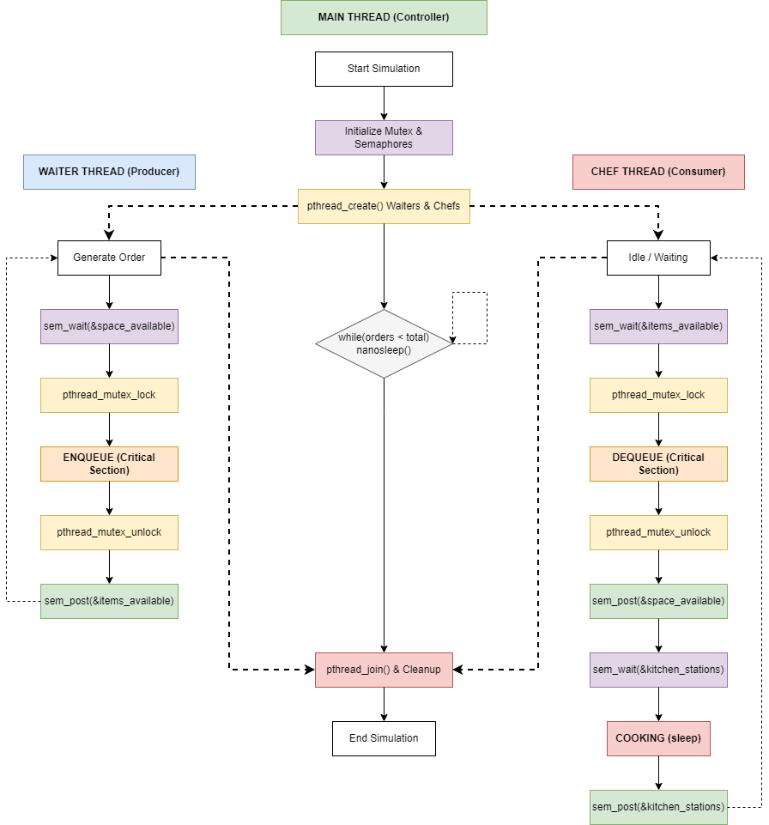

4. Conclusion
The simulation effectively uses POSIX Pthreads and Semaphores to resolve a multi-layered Producer-Consumer challenge. The architectural choice to separate queue management from cooking stations prevents deadlock, while the mutex ensures thread-safe modification of the shared order array. The project accurately models concurrent hardware-like scheduling logic within an OS context.

5. References
IEEE Reference Guideline.
Operating Systems Concepts, 10th Edition (Silberschatz).

